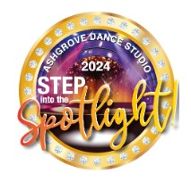

|  |  |  |
| --- | --- | --- |
|  | Dance | Class |
| 1 | The audition | Broadway Jazz |
| 2 | Bolero | Ballet |
| 3 | I've got Rhythm | Adult Tap |
| 4 | Judith | Ballet |
| 5 | Skyfall | Eist |
| 6 | Let It Happen | Contemporary |
| 7 | Hip Hop | Elka & Luca |
| 8 | Symphony in C | Adult Ballet |
| 9 | Don't Want to Miss a Thing | Ballet |
| 10 | Fun Jazz | Adult Jazz group |
| 11 | Let's Get Loud | Adv Jazz |
| 12 | Impossible Dream | Adult Ballet |
| 13 | 2nd Contemporary | Contemporary |
| 14 | Gotta Tap | Gotta Tap |
| 15 | He's a Pirates | Senior Ballet Girls |
| 16 | I'm a Brass Band | Adult Tap |
| 17 | Sway | Dirty Dancing |
| 18 | Thriller | Jazz group |
| 19 | I want to be a Rockette | Chorus girls and guys |
| 20 | Finale | All ADS Company |