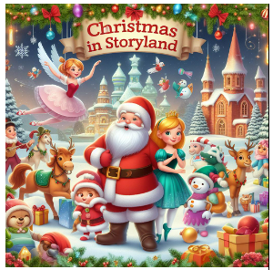

 | Dance | Class
1 | Intro
2 | Chefs | Jnr Tap
3 | Christmas cookies | New Primary - (Pre Primary)
4 | Be our guest | New Grade 3 (Grade 2)
5 | Sugar Plum fairies | Grade 5 & Int Foundation 1
6 | Sugar Plum Fairy
7 | Dolls & Nutcracker Soliders | New Grade 2 (Grade 1)
8 | Doll Dance
9 | Storybook waltz | Snr Ballet Students
10 | Christmas Garlands | New Grade 4 (Grade 3)
11 | Christmas Presents | New Grade 1 (Primary)
12 | Lights the Christmas tree fairies | New Grade 5 (Grade 4)
13 | Snowflakes | Int
14 | The Grinch & Hip hop boys | The Grinch
15 | Better when I'm dancing | Beg Jazz & Jnr Jazz
16 | Christmas jazz | Snr Jazz Monday
17 | Santa Reindeers | Beg Ballet
18 | Santa helpers | Int Tap
19 | Christmas Elves | Creative Movement & Tiny Tots
20 | 12 Days of Christmas | Snr & Adv Tap
21 | Finale | All

